
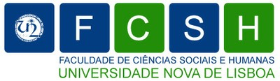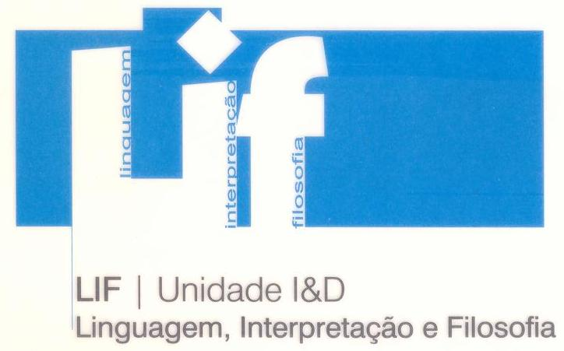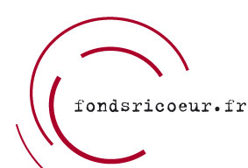



International Symposium Reading Ricoeur Once Again: Hermeneutics and Practical Philosophy Programme

Wednesday 7th July

8.30 – Welcome

9.30 – Opening Session – António Manuel Rendas (Rector, UNL), João Sàágua (Dean, FCSH), António Martins (Coordinator, LIF), Luís Manuel Bernardo (Vice-Director, CHC), Gonçalo Marcelo (Organizing Committee), George Taylor (President, Society for Ricœur Studies), Catherine Goldenstein (Curator, Fonds Ricœur), Andrzej Wiercinski (President, International Institute for Hermeneutics)

10.15 – Coffee Break

10.30 – George Taylor (University of Pittsburgh) – Ricoeur and Just Institutions.

11.30 – Gilbert Vincent (Université de Strasbourg) – Entre Herméneutique et Sciences Sociales, le concept d’institution.

12.30 – Lunch

14.00 – Parallel Sessions 1, 2, 3 and 4

16.00 – Coffee Break

16.15. – Parallel Sessions 5, 6, 7 and 8

18.30 – Multimedia session with videos on Ricoeur

20.00 – Welcome Dinner

Thursday 8th July

09.00 – Parallel Sessions 9, 10, 11 and 12

11.00 – Coffee Break

11.15 – Michel Renaud (Universidade Nova de Lisboa) – L’articulation de la philosophie de la religion sur la raison pratique selon Paul Ricœur.

12.15 – Daniel Frey (Université de Strasbourg) – De la religion, comprise comme possibilité de régénérer la capacité humaine.

13.15 – Lunch

14.30 – Parallel Sessions 13, 14, 15 and 16

16.30 – Coffee Break

16.45 – Richard Kearney (Boston College) – Ricœur’s Hermeneutics of Hospitality.

17.45 – David Pellauer (DePaul University) – Looking for the Just.

19.00 – Dinner

20.00 – Business Meeting

Friday 9th July

09.00 – Parallel Sessions 17, 18, 19 and 20

11.00 – Coffee Break

11.15 – Jérôme Porée (Université de Rennes) – Les limites du récit.

12.15 – Andrzej Wiercinski (Albert-Ludwigs-Universität, Freiburg) – A Healing Journey toward Oneself: Paul Ricoeur’s Narrative Turn in the Hermeneutics of Education.

13.15 – Lunch

14.30 – Parallel Sessions 21, 22, 23 and 24

16.30 – Coffee Break

16.45 – Maria Luísa Portocarrero (Universidade de Coimbra) – Penser à nouveau l´identité: subjectivité, aliénation et narration chez Ricoeur.

17.45 – Alison Scott-Bauman (University of Gloucestershire) – Negativity: toxic or vital? Ricœur’s early work on negation.

20.00 – Closing Dinner

Saturday 10th July

09.00 – Parallel Sessions 25, 26, 27 and 28

11.00 – Coffee Break

11.15 – Johann Michel (Université de Poitiers, EHESS) – Construire une sociologie herméneutique en venant de Ricœur.

12.15 – Fernanda Henriques (Universidade de Évora) – De la volonté motivée à l'identité narrative: un parcours de reconnaissance avec Paul Ricoeur.

13.15 – Lunch

14.30 – Parallel Sessions 29, 30, 31 and 32

16.15 – Coffee Break

16. 45 – Michaël Foessel (Université de Bourgogne) – De l’action aux institutions: les pouvoirs de l’imaginaire.

17.45 – Axel Honneth (Johann Wolfgang Goethe- Universität, Frankfurt am Main) – The Fabric of Justice. On the limits of proceduralism.

19.00 – Symposium’s closing

20.00 – Dinner

